KINDLY SPONSORED BY ‘THE NORTHERN SNOOKER CENTRE’

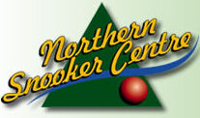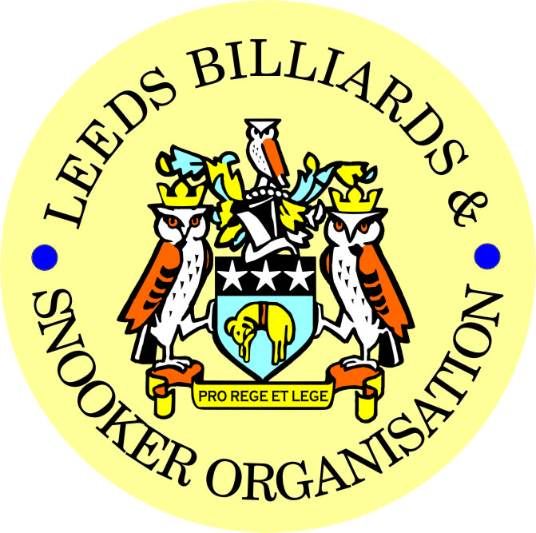

**PRIZE PRESENTATION EVENING**
**WEDNESDAY 9th JULY 2014**
** BRAMLEY BAND CLUB**

** LEEDS CITY CHAMPIONSHIPS - JUNIORS **
U.16’s & U.18’s - SNOOKER

UNDER 16’s SNOOKER:
WINNER: ROBERT THOMPSON | RUNNER-UP: CALLUM BERESFORD
SEMI-FINAL: JOE DIXON | SEMI-FINAL: SAM GREGORY
UNDER 18’s SNOOKER:
“The Keith Weston Memorial Trophy”- Sponsored by ADT Flexibles (UK) Ltd.
WINNER: OLIVER MULCAHY | RUNNER-UP: LIAM BARLOW
SEMI-FINAL: JAKE BELL | SEMI-FINAL: SAM GREGORY
JUNIOR HIGH BREAK:
“The Paul Hunter Memorial Trophy” – OLIVER MULCAHY (55)

**2013-14 YBSA – YORKSHIRE INTER-DISTRICT LEAGUES**

BILLIARDS LEAGUE  CHAMPIONS  LEEDS  (For the 8th consecutive year)  Squad Players: | SNOOKER LEAGUE – DIVISION 1  LEEDS  Squad Players:
Johnathan Bagley (Captain) | Anthony Massey (Captain)
Bob Patterson | John Gillen
Dave Barker | Ian O’Brien
 | Mark Ball
 | Lewis Gillen
 | Tommy Doherty

SNOOKER - “Veterans Trophy” | REFEREES:  Officiated in 2013-14 LBSO Competitions:
WINNER: Howard Brazil | KENNETH SYMONS
RUNNER-UP: Dave Taylor | RICHARD LILLIE
 | ALEX CRUM
PLATE WINNER: Paul Grimes | MICHAEL DAVENPORT
PLATE RUNNER-UP: Bernard Abbott | IAN WALKER
 | PETER WALKER
 | BOB PATTERSON

Break for Entertainment – Main Presentation to follow afterwards:

** LEEDS CITY CHAMPIONSHIPS **

BILLIARDS:
WINNER: JOHNATHAN BAGLEY | RUNNER-UP: DAVE BARKER
INDIVIDUAL SNOOKER:
WINNER: JOHNATHAN BAGLEY | RUNNER-UP: OLIVER LINES
SEMI-FINAL: SCOTT RAPER | SEMI-FINAL: DANIEL WOMERSLEY
PAIRS SNOOKER:
WINNERS: J.BAGLEY / O. LINES | RUNNERS-UP: P. GOODALL / M. SAVERY
SEMI-FINAL: P. GRIMES / A. TAFFINDER | SEMI-FINAL: L.GILLEN / S. STEVENS
TEAM SNOOKER – “The Jim Fowler’s Trophy”:
WINNERS: NORTHERN S.C. ‘A’ | RUNNERS-UP: NORTHERN S.C. ‘B’
SEMI-FINAL: NEW WORTLEY LABOUR | SEMI-FINAL: GARFORTH WMC

LEN LEE INVITATION SNOOKER:  “THE LEN LEE TROPHY” | WINNER: JOHNATHAN BAGLEY  RUNNER-UP: SCOTT RAPER  SEMI-FINALIST: TOMMY DOHERTY  SEMI-FINALIST: DAVE BARKER

** LBSO - BILLIARDS & SNOOKER LEAGUES **

Div: | CUP TITLE / WINNERS: | RUNNERS-UP:
Billiards | The Yorkshire Evening News Cup:  SWARCLIFFE WMC | LPSA
Div A | The Yorkshire Evening News Shield:  NEW WORTLEY LABOUR | NORTHERN S.C. ‘B’
Div B | The Clan Tartan Trophy:  ACKROYD STREET ‘A’ | NORTHERN S.C. ‘E’
Div C | The John Dunning Trophy:  EAST END PARK ‘B’ | TINSHILL & COOKRIDGE ‘A’
Div D | The J. H. Lunn Cup:  EDMUND HOUSE ‘A’ | BELLE ISLE WMC ‘B’
Div E | The Peter Nelson Trophy:  ARMLEY LIBS | FARSLEY CONS
Div F | The Peter Hawkyard Memorial Trophy:  GARFORTH WMC ‘A’ | CORPUS CHRISTI ‘A’
Div G | The Joe McDonnell Trophy:  147 SPORTS BAR | IRELAND WOOD ‘B’
Div H | The Keith Darley Trophy:  TINSHILL & COOKRIDGE ‘C’ | MOOR ALLERTON ‘B’

“CHAMPION of CHAMPIONS”  “The Jim Williamson Memorial Trophy” | WINNERS: GARFORTH WMC ‘A’  (DIVISION F WINNERS)
SNOOKER – Individual Handicap.
The “GEORGE SYKES CUP”
WINNER: SAM O’BRIEN  (HAREHILLS WMC) | RUNNER-UP: CRAIG MOLNAR  (CROSSAGTES WMC)
SEMI-FINAL: DARREN BINNS  (HUNSLET CARR SPORTS & SOCIAL) | SEMI FINAL: LUKE NAYLOR-HAIGH  (PEGGY TUB SOCIAL)

SNOOKER – Pairs Handicap.
The “LEN LEE CUP”
WINNERS: L.GILLEN / N. MORTIMER  (NEW WORTLEY LABOUR) | RUNNERS-UP: J.BAGLEY / A. CONBOY  (HAREHILLS LABOUR)
SEMI-FINAL: I. O’BRIEN / S. O’BRIEN  (HAREHILLS WMC) | SEMI-FINAL: A.AVEYARD / M. BOOTH  (ROTHWELL WMC)

SNOOKER - 3 MAN TEAM KNOCK OUT.
The “Leeds & District Billiards League Snooker Cup”
WINNERS: UPPER & LOWER WORTLEY LIBS | RUNNERS-UP: QUEENSWOOD SOCIAL
SEMI-FINAL: EAST LEEDS S.C. | SEMI FINAL: GARFORTH WMC

BILLIARDS HANDICAP:  “YORKSHIRE EVENING POST SHIELD” | WINNER: JOHNATHAN BAGLEY  RUNNER-UP: CHARLIE BOYLE

** STAN BROOKE MEMORIAL COMPETITIONS **
INDIVIDUAL SNOOKER:
WINNER: KRIS CHAPMAN  (CROSSGATES REC. HALL) | RUNNER-UP: ROB JOHNSON  (BRAMLEY VILLAGERS)
SEMI-FINAL: GARETH NAYLOR  (PEGGY TUB SOCIAL) | SEMI-FINAL: MARK ASPIN  (MIDDLETON CONS)
PAIRS SNOOKER:
WINNERS:  G. GRIFFIN / A. BEDFORD  (HOLBECK WMC) | RUNNERS-UP:  - MASSEY / S. O’BRIEN  (HAREHILLS WMC)
SEMI-FINAL  Paul GRIMES / Lee GRIMES  (ACKROYD STREET) | SEMI-FINAL:  Martin McGUIGAN / Charlie McGUIGAN  (BRAMLEY BAND CLUB)
TEAM SNOOKER:
WINNERS: BEESTON HILL SOCIAL | RUNNERS-UP: EAST LEEDS S.C.
SEMI-FINAL: CROSSGATES REC. HALL | SEMI-FINAL: HAREHILLS LABOUR

The “WINDSOR TROPHY” – 4 Man Team Handicap

WINNERS: SWARCLIFFE WMC | RUNNERS-UP: NORTHERN S.C.
SEMI-FINAL: BELLE ISLE WMC | SEMI FINAL: CROSSGATES WMC

LBSO LEAGUE - HIGHEST BREAKS – BILLIARDS & SNOOKER
Billiards ‘A’ – (-200 to +19) | 136 – Johnathan Bagley (-215) – Swarcliffe WMC
Billiards ‘B’ – (+20 to +200) | 38 – Warren Hall (+90) – South Leeds Cons
Snooker – Group 1 (-80 to -20) | 134 – Johnathan Bagley (-53) – Harehills Labour
Snooker – Group 2 (-19 to +5) | 94 – Keith Dawson (-4) – Holbeck WMC
Snooker – Group 3 (+6 to +20) | 85 – Ryan Walton (+8) – Excelsior S.C.
Snooker – Group 4 (+21 to +30) | 59 – Tim Lambert (+23) – Swarcliffe WMC
Snooker – Group 5 (+31 to +80) | 47 – Johnathan Ramsden (+40) – Holbeck WMC

CONGRATULATIONS TO
ALL PRIZE WINNERS!

The LBSO would like to thank the Committee and Members of
Bramley Band Club for staging their Presentation Night this year.

A.G.M.

MONDAY 14th JULY 2014 – 7-45pm
at
HOLBECK WMC

PRESIDENT – CHRIS WILLIAMSON
CHAIRMAN – RODNEY SIMS
VICE CHAIRMAN – ANDY TAFFINDER
LEAGUE SECRETARY – PAUL GRIMES
GENERAL SECRETARY / TREASURER – BOB PATTERSON

The LBSO would like to thank the Committee and Members of Holbeck WMC, for allowing us the use of the club for LBSO delegate meetings and the AGM, throughout this season and in the past.

Produced By
Kindly Sponsored by the ‘NORTHERN SNOOKER CENTRE’

